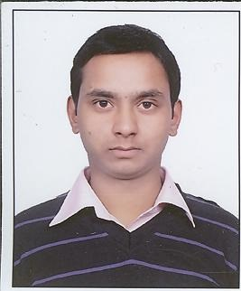
ACADEMIC CREDENTIALS
- ADCHN (Advance Diploma in Computer Hardware and Networking).
- B.A (Bachelor of Art) Form Choudhary Charan Singh University Meerut in 2013
- 12th from Raj public Academy, U.P. Board in 2010, Secured 50.80 % marks.
- 10th from Calpana Chawla Inter Collage, U.P Board in 2007 Secured 50.50% Marks.
- A.D.C.A.( Advance diploma in computer application) Form HNet in Delhi 2010
PERSONAL DOSSIER
Date of Birth : 12th June 1991
Linguistic Abilities : English and Hindi
Current Address : 928/8 Govindpuri

AFSAR KHAN A
PROFESSIONAL SNAPSHOT

- Dynamic Graduated individual with ADCHN (Advance Diploma in Computer Hardware and Networking) from NSIC (National Small Industrial Center).
Functional responsibilities as Quality analyst :-

- To audit the number of calls given by the client on a
daily basis
- Record feedback and to let the Customer service to know
about his/hers areas of improvements.
- Bring in necessary changes to the process and constant
updation of call centre core process
- To check whether the Agents has incorporated Knowledge and
competence and the customer was able to comprehend to what
the Agent was talking about
- To check if the Agents has used the right telephone
etiquettes, followed appropriate hold procedures and has
a given a proper resolution for the customer’s request.
- Attend call calibrations with the client.
- Shared the instant Feedback of Fatal calls to the Agent.

Experience
- I am working with Vertex Customer Management (Noida’ Sector-4) on a Project Flipkart (Voice, Inbound Process) form 19th September 2015 To till Now as Quality Analyst.

PERSONAL DOSSIER
Name : Afsar Khan
Father’s Name : Inam Elahi Khan
Nationality : Indian
Gender : Male
Date of Birth : 12th June 1991
Permanent Address : 928/8 Govindpuri Kalkaji New Delhi
Contact No. : 9711042697
Email : afsar.khan1991@gmail.com

HOBBIS
- Create a Collaborative Environment
- Searching new ideas to improve Process.
- Be aware about the Process Requirement and new challenges.

REFEREES
Shall be available on Request

